

Moving Forward on Data Infrastructure Technology Convergence

Expert Meeting: 28/29.10.2019.

at the Observatoire of Paris

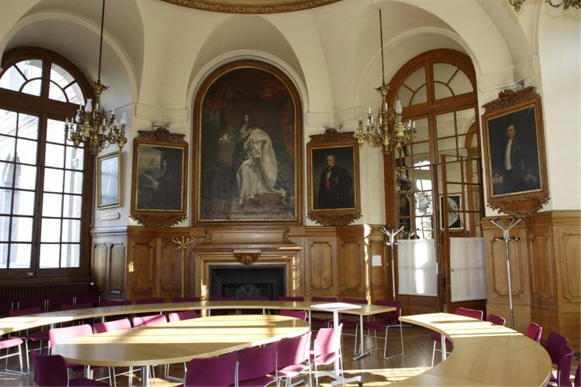

# Goal of the Meeting

The goal of the meeting is to decide on a **Joint Agreement on FAIR Digital Objects** stating the requirements for FAIR Digital Objects and to agree on a governance structure to advance FAIR DO development. The contributions and discussion aim for a constructive approach towards these goals. We welcome by the way all participants to come up with a better label for the declaration, since it should be remembered.

Label Suggestions:

Joint Agreement on FAIR Digital Object Specifications” - people will use “The Paris Agreement"

**P**aris **A**greement on **R**esearch **I**nfrastructure **S**tandards Declaration, Giving **P.A.R.I.S Declaration**

# Agenda

### Day 1 - 28. 10. 2019

### 12.00 Reception and Coffee

### 13.00

Carlo Zwölf: Welcome

### 13.10 - 13.45 Session 1: Introduction to FAIR DO

Session Chair: Carlo Zwölf

* Peter Wittenburg: From Kahn Papers to RDA DFT DO Core Model
* Luiz Bonino: Extending the model to FAIR DO

Peter and Luiz will give a brief overview about the developments and motivations that led us to define the FAIR DO concept.

### 13.45 - 16.00 Session 2: Community Experts

Session Chair: Francoise Genova

We invited several speakers from active infrastructure building communities to present their data-related needs and ideas and relate them with the FAIR DO concept.

* Dimitris Koureas (Biodiversity)
* Tobias Weigel (Climate Modelling)
* Koenraad de Smedt (Language research)
* Barend Mons (Infrastructure Biomedical)
* Roberto di Cosmo (Software Development)
* open discussion

Each speaker has 15 minutes to briefly describe the main challenges when building data infrastructures and to explain whether the concept of FAIR DO can be of help to solve major data infrastructure problems. We ask all speakers to present just 3 slides to address three questions:

* Which are the major challenges in your infrastructure building efforts?
* How would the FAIR DO concept help you to overcome essential challenges?
* Which requirements do you see which are currently not addressed by the FAIR DO concept?

### 16.00 - 16.30 Coffee Break (could also be done within the previous session)

### 16.30 - 18.00 Session 3: Requirement Specifications

Session Chair: Bob Hanisch

This session is meant to present requirements that influence the specification of the FAIR DO concept. Some additional requirements will have been addressed by the scientific community speakers. We see two other areas from which requirements will evolve: FAIR Maturity Indicators (Keith) and proper citation principles (Carlo). Keith and Carlo will describe their requirements and have 10 minutes each. Larry will summarise the requirements and relate them with what has already been specified.

* Edit Herczog: Requirements emerging from RDA FAIR Maturity Indicators
* Carlo Zwölf: Requirements emerging from proper Citation
* Larry Lannom: Presentation of the Requirements so far
* Open Discussion about possible changes of the Requirements

### 19.30 Joint Dinner

### Day 2 - 29. 10. 2019

### 9.00 -10.00 Session 4: Short Comments from Technologists on the Requirements

The requirements specified refer back to many discussions in CNRI, RDA, DONA, GOFAIR, GEDE etc. and many technical and domain experts have been involved. In addition, first implementations of DO components have already been developed and the LD Community has many examples in place. However, we also know that much more needs to be done to come to a fully functioning data infrastructure enabling machine-mediated data processing. Therefore, we invite some experts from different background to make short statements on the technical requirements and what remains missing based on their broad experience. Each speaker will have 5 minutes to comment on 3 key points that reflect on the requirements, leaving sufficient time for discussions.

Session Chair: Erik Schultes

* Christophe Blanchi
* Jonathan Clark
* Ray Plante
* Klaas Wierenga

### 10.00 - 10.30 Coffee Break

### 10.30 - 11.45 Session 5: Comments on Paris Agreement and Governance Structure

Session Chair: Jean Francois Abramatic

Barend and Robert will open the session by presenting their views on the Paris Declaration to be presented to the outside world and for possible governance structures to push the FAIR DO development. Each will take 15 minutes. Afterwards we will have short contributions from some experts who look from a more external point of view and then open the discussion. Also here it would be good to have 3 key points being raised by the colleagues.

* Barend Mons: Memorandum on FAIR DO
* Robert Quick: Possible Governance Structures

Commenters

* Edit Herczog
* Mark Leggott
* Michel Schouppe

### 11.45 - 13.00 Session 6: Conclusions

Session Chair: George Strawn

George will summarise his impressions about the meeting so far and describe the rough consensus that has been achieved on the requirements being formulated, on the Paris Agreement and the directions with respect to the organisational form. One or two Working Group(s) will be formed that will further work on these topics. George statements will be followed by an open discussion about the tasks of these WG(s).

### 13.00 End and Lunch

### Participants

Jean Francois Abramatic (EOSC), Christophe Blanchi (DONA), Luiz Bonino (GOFAIR), Bonnie Carroll (DENDI), Massimo Cocco (EPOS), Roberto di Cosmo (INRIA), Jonathan Clark (IDF), Julien Forest (Artenum), Francoise Genova (RDA), Bob Hanish (NIST), Alex Hardisty (DISSCO), Edit Herzcog (RDA), Anders Sparre Konrad (Danish RC), Dimitris Koureas (DISSCO), Larry Lannom (CNRI), Mark Leggott (Research Data Canada), Barend Mons (CODATA, GOFAIR), Beth Plale (NSF) tbc, Ray Plante (NIST), Robert Quick (IU), Michel Schouppe (EC), Erik Schultes (GOFAIR), Koenraad de Smedt (CLARIN), George Strawn (BRDI), Zsuzsanna Szeredi (GEDE), Tian Ye (CNIC-CAS), Tobias Weigel (ENES), Klaas Wieringa (GEANT), Mark Wilkinson (U Madrid), Peter Wittenburg (RDA GEDE), Carlo Zwölf (VAMDC)

## Organisers

Edit Herzcog (RDA), Barend Mons (GOFAIR, CODATA), Larry Lannom (CNRI), Robert Quick (IU), George Strawn (BRDI), Peter Wittenburg (GEDE), Carlo Zwölf (VAMDC, GEDE)

Assisted by: Zsuzsanna Szeredi (GEDE)